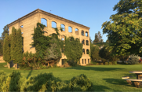
Kaleden Community Association
Box 136, Kaleden, BC, VOH 1K0
250-497-6985
chair@kaledencommunity.com

Kaleden Community Association
Grant Funding Criteria

- Applicant(s) must be a resident of Kaleden.

- Grant is open to all ages.

- Grant activity or purpose must engage and/or connect residents of Kaleden and enhance opportunities for participation.

- Grant funding is limited to a maximum of $250.00, once a calendar year.

- Grant application may be submitted at any time – chair@kaledencommunity.com or Box 136, Kaleden, BC, V0H1K0

- Applications may be requested by contacting KCA at either of the above addresses.

