RE: Support for the conservation of Sickle Point
To Whom it May Concern,
I am writing to add my support to the grassroots movement that has emerged in support of conserving Sickle Point for its substantial social and environmental value.
This parcel contains federally identified critical habitat for yellow-breasted chat, Lewis’s woodpecker, pallid bat, and several snake species at risk. This parcel also represents one of the few remaining naturally vegetated foreshore areas on Skaha Lake. Based on these and other factors, the parcel has been ranked at a very high conservation value as part of the South Okanagan Similkameen Biodiversity Conservation Strategy.
Multiple stakeholders have come together to identify a shared interest in conservation of this site. Clearly the community groups are most important, though it’s also noteworthy that all levels of government also have expressed an interest: the Penticton Indian Band (Chief Greg Gabriel), Local government Regional District Director (Subrina Montheith), provincial MLA (myself), and federal MP (Richard Cannings) have all expressed support for protection of the site. This is a partnership.
Financial support is key to the conservation of this site, and the current plan from the community includes raising funds from numerous sources. I understand that the Ministry of Forests Lands Natural Resource Operations and Rural Development (FLRNORD) is currently evaluating the parcel, but is unable to contribute financially at this time. The community itself simply doesn’t have the resources to bear the full burden of the costs of conservation, although significant funds have been raised from within the community itself. Your ability to contribute funds to this project would be an enormous asset to the protection of this site.
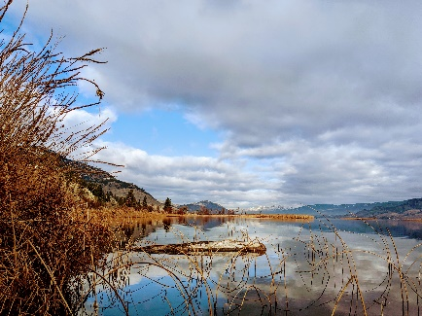
I support projects such as this because they provide significant and permanent positive impacts to this community and enhance social and environmental values that have been identified from the community.
Sincerely,

Roly Russell
MLA for Boundary – Similkameen

