Box 851
Summerland, BC
V0H 1Z0
February 8, 2021

To: Sickle Point Committee
Re: Ecological Restoration

The Sickle Point property, if purchased, presents an outstanding opportunity for the restoration of natural systems, also known as ecological restoration. Sickle Point encompasses five distinct ecosystem types: aquatic, submerged aquatic (ie, cattails and bulrushes), riparian, mesic dryland and xeric dryland. The riparian and dryland types have been heavily impacted by soil disturbance and logging. In addition, non-native trees, shrubs, forbs and grasses are present.

This site is an ideal educational laboratory for ecological restoration (ER), perhaps in partnership with a university, college, First Nation entity or a non-profit society (such as the Society for Ecological Restoration-Western Canada). This would provide hands-on opportunities for students and adult learners to engage with the complexities of ER, including invasives removal, soil and bank stabilization, native seed collection, transplanting, habitat creation etc. With appropriate signage, the ER works could also serve to educate passersby and occasional visitors to the site.

There is a non-technical, philosophical aspect of ER that goes beyond simply connecting people with nature. It is best summed up by the ER pioneer William Jordan, whom I am paraphrasing here:

There is an inherent tension between people and nature, even in so-called primitive societies.
One of the basic functions of human culture is to mediate that tension. A key component of cultural mediation is ritual. Ritual has been with us since the beginning of human history, and yet ritual is almost completely absent from our contemporary lives. The practice of ER represents a brilliant opportunity to re-insert ritual into contemporary life.

In short, Sickle Point offers a host of intriguing possibilities. I wish you best of luck with the project, and I am willing to help in any way I can.

Sincerely,
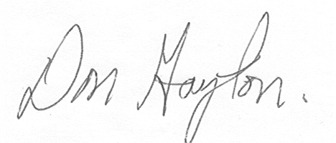

Don Gayton, M.Sc, P.Ag

